
JC2 PRELIMINARY EXAMINATION
TAMPINES MERIDIAN JUNIOR COLLEGE

_________________________________________________________________________________
H1 GEOGRAPHY 8834/01

Paper 1 12 September 2024 3 hours
INSERT

_________________________________________________________________________________

READ THESE INSTRUCTIONS FIRST

This Insert contains all the Resources referred to in the questions.

_________________________________________________________________________________

This document consists of 8 printed pages
Resource 1 for Question 1

A map showing the locations of electric vehicle charging stations in Tampines
where the students carry out their survey

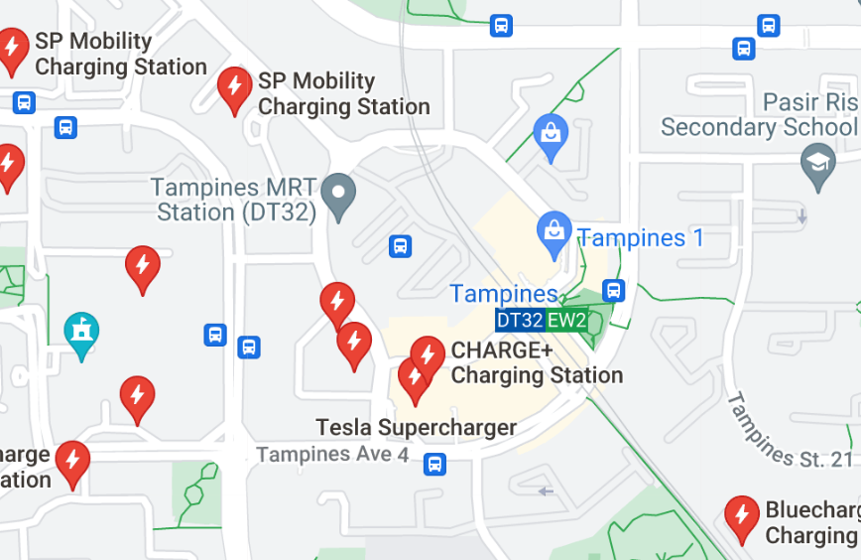
C
B
A
A
(An Enlarged View of the Central Area in Tampines)

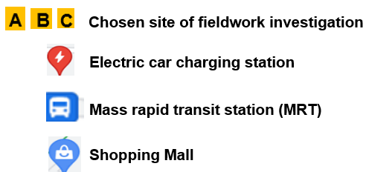

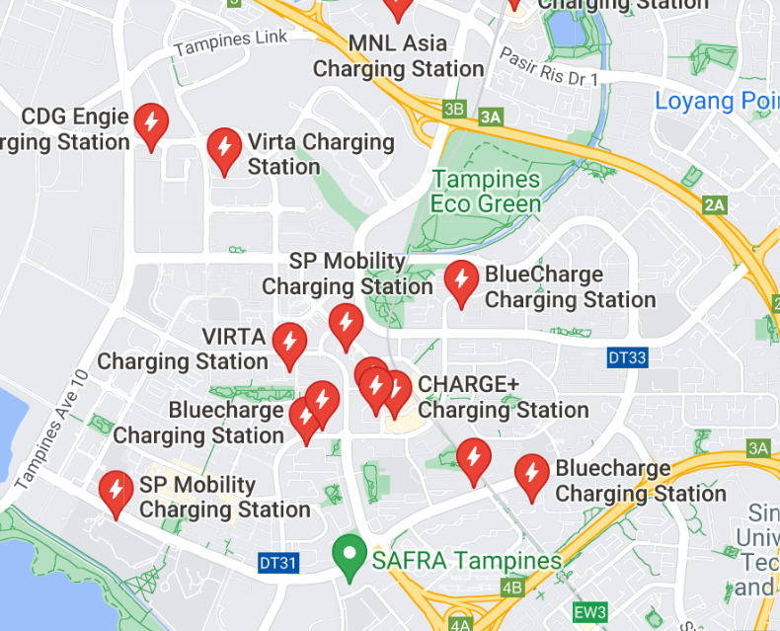
Resource 2 for Question 1

Questionnaire used by the students for the survey

Name:______________________________________

Age: ____________________ Gender:__________________

- How many years have you been driving? _________________

- Would you consider buying an electric car as your primary mode of transport?

Yes / No / Maybe (please circle your answer)

3. Which of the following factors would influence your decision to purchase an electric car?

        - EV is environmentally friendly.

- Strongly influence
- Some influence
- No influence

        - Availability of government subsidies to buy EV.

- Strongly influence
- Some influence
- No influence

        - EV offers greater ease and comfort in driving.

- Strongly influence
- Some influence
- No influence

        - EV offers savings in fuel cost.

- Strongly influence
- Some influence
- No influence

        - There is easy accessibility to charging for EV.

- Strongly influence
- Some influence
- No influence

Resource 3 for Question 1

Selected results of the questionnaire survey

% of respondents (out of 50 surveyed)
Factors that encourage Tampines drivers to purchase electric vehicles (EV) for daily use | Strongly influence | Some influence | No  influence
EV is environmentally friendly. | 4% | 76% | 20%
Affordability of EV | 60% | 30% | 10%
Availability of government subsidies | 38% | 52% | 10%
Greater ease and comfort in driving | 24% | 66% | 10%
Savings in fuel cost | 74% | 26% | 0%
Easy accessibility to EV charging stations | 50% | 30% | 20%

Resource 4 for Question 2

Global population living in urban areas by continent from 1950 to 2030

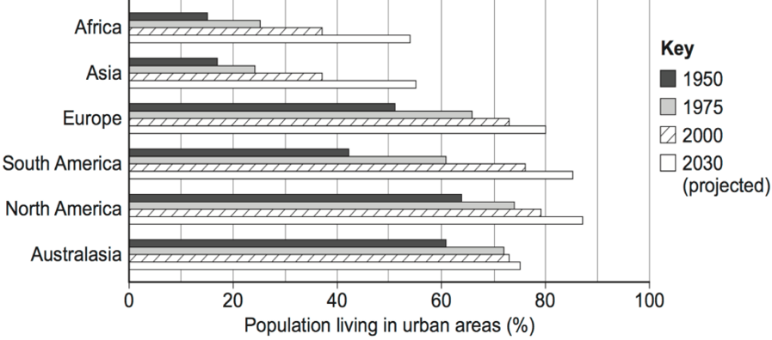

Resource 5 for Question 2

Graph depicting the relationship between urbanisation level and GDP per capita
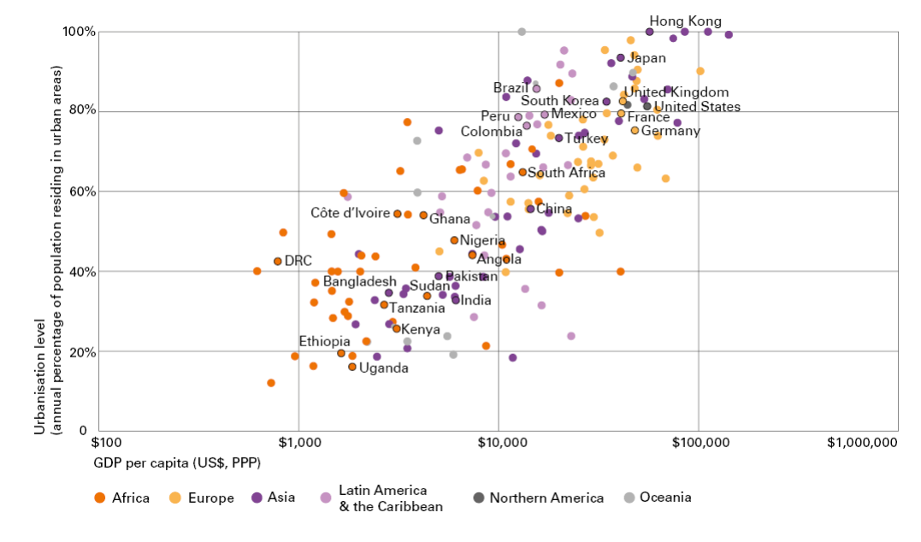
Resource 6 for Question 2

An extract from the Sustainable Development Goals Report 2022

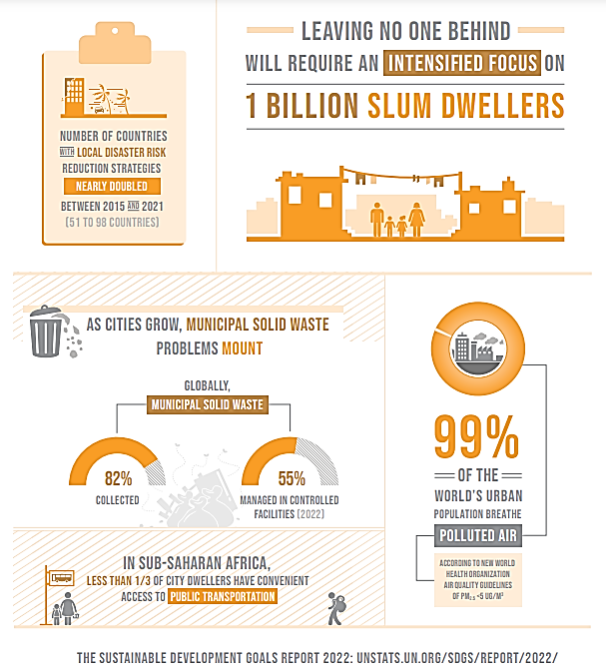

Resource 7 for Question 3

A map showing the global waste production in 2018 (in kilogram per capita)

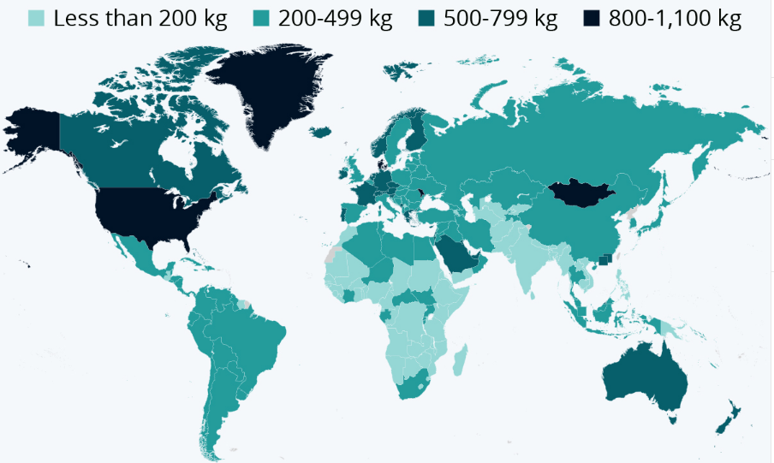

Resource 8 for Question 3

Total amount of waste generated by different activities in Kazakhstan, Denmark
and United Kingdom in 2018 (measured in tonnes)

 | Kazakhstan | Denmark | United Kingdom
Agriculture, Forestry and Fishing | 2.1 million | 3.7 million | 8 million
Construction | 4.8 million | 12 million | 138 million
Manufacturing | 28.1 million | 1 million | 11.2 million
Households | 2.1 million | 3.5 million | 26.4 million
Others | 7.4 million | No data | No data

Resource 9 for Question 3

Annual greenhouse gas emissions from waste

